**U.P. RAJKIYA NIRMAN NIGAM LTD.**



**PRELIMINARY DETAILED ESTIMATE**

**FOR**

**PROPOSED CONSTRUCTION OF 150 NOS.GOVERNMENT I.T.I. IN U.P.**

**(OPTION- 4)**

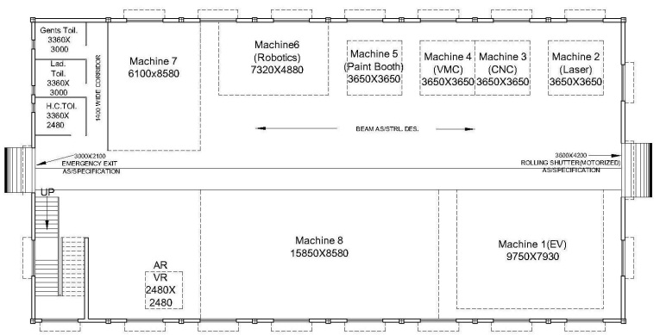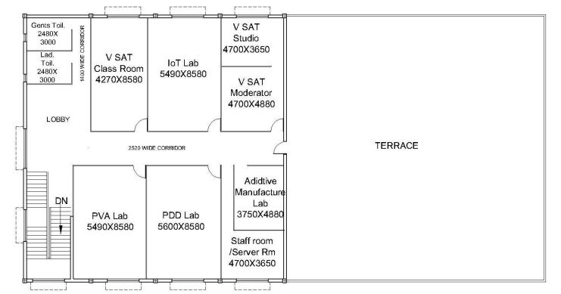

**ESTIMATED COST OF WORK Rs. 476.85 LACS**